Churn Reduction

Sanjib Kumar Mishra

**Contents**

1 Introduction

* 1. Problem Statement
  2. Data
  3. Exploratory Data Analysis

1. Methodology

2.1 Pre Processing

* + 1. Missing Value Analysis
    2. Outlier Analysis
    3. Feature Selection
    4. Class Imbalance
  1. Modeling
     1. Model Selection
     2. Model Evaluation

1. Conclusion

Appendix 1 – Extra Figure

Appendix 2 – R Code

Appendix 3 – Python Code

**Chapter 1**

**Introduction**

**Customer Churn**

Customer churn occurs when customers or subscribers stop doing business with a company or service, also known as customer attrition. It is also referred as loss of clients or customers. In telecommunication industries churn rates are particularly useful as the customer have multiple options from which to choose within a geographic location.

* 1. **Problem Statement**

The objective of this Case is to predict customer behavior. Here I got a public dataset that has customer usage pattern and if the customer has moved or not. I have to develop an algorithm to predict the churn score based on usage pattern.

**1.2 Data**

Dataset Details:

For this project I have train and test dataset. So, first step towards my project is to develop the model on train data, then validate the model with the test data.

The details of the train and test data are as follows;

**Train Data**

**dim(train)**

**Output:** [1] 3333 21

Here my train data has 3333 observations and 21 variables.

**Test Data**

**dim(test)**

**Output:** [1] 1667 21

The test data contains 1667 observations and 21 variables.

**Variables details:**

**colnames(train)**

[1] "state" "account.length"

[3] "area.code" "phone.number"

[5] "international.plan" "voice.mail.plan"

[7] "number.vmail.messages" "total.day.minutes"

[9] "total.day.calls" "total.day.charge"

[11] "total.eve.minutes" "total.eve.calls"

[13] "total.eve.charge" "total.night.minutes"

[15] "total.night.calls" "total.night.charge"

[17] "total.intl.minutes" "total.intl.calls"

[19] "total.intl.charge" "number.customer.service.calls"

[21] "Churn"

* Out of 21 variables “Churn” variable is my target variable which having two class i.e. False and True.
* Here True means customer has moved and False means customer has not moved

**Exploratory Data Analysis**

Before doing the exploratory analysis let’s check the structure of the dataset.

#Structure of the dataset

|  |
| --- |
| **str(train)**  'data.frame': 3333 obs. of 21 variables:  $ state : Factor w/ 51 levels "AK","AL","AR",..: 17 36 32 36 37 2 20 25 19 50 ...  $ account.length : int 128 107 137 84 75 118 121 147 117 141 ...  $ area.code : int 415 415 415 408 415 510 510 415 408 415 ...  $ phone.number : Factor w/ 3333 levels " 327-1058"," 327-1319",..: 1927 1576 1118 1708 111 2254 1048 81 292 118 ...  $ international.plan : Factor w/ 2 levels " no"," yes": 1 1 1 2 2 2 1 2 1 2 ...  $ voice.mail.plan : Factor w/ 2 levels " no"," yes": 2 2 1 1 1 1 2 1 1 2 ...  $ number.vmail.messages : int 25 26 0 0 0 0 24 0 0 37 ...  $ total.day.minutes : num 265 162 243 299 167 ...  $ total.day.calls : int 110 123 114 71 113 98 88 79 97 84 ...  $ total.day.charge : num 45.1 27.5 41.4 50.9 28.3 ...  $ total.eve.minutes : num 197.4 195.5 121.2 61.9 148.3 ...  $ total.eve.calls : int 99 103 110 88 122 101 108 94 80 111 ...  $ total.eve.charge : num 16.78 16.62 10.3 5.26 12.61 ...  $ total.night.minutes : num 245 254 163 197 187 ...  $ total.night.calls : int 91 103 104 89 121 118 118 96 90 97 ...  $ total.night.charge : num 11.01 11.45 7.32 8.86 8.41 ...  $ total.intl.minutes : num 10 13.7 12.2 6.6 10.1 6.3 7.5 7.1 8.7 11.2 ...  $ total.intl.calls : int 3 3 5 7 3 6 7 6 4 5 ...  $ total.intl.charge : num 2.7 3.7 3.29 1.78 2.73 1.7 2.03 1.92 2.35 3.02 ...  $ number.customer.service.calls: int 1 1 0 2 3 0 3 0 1 0 ...  $ Churn : Factor w/ 2 levels " False."," True.": 1 1 1 1 1 1 1 1 1 1 ...  . |
|  |
| |  | | --- | | Here I removed state,account.length, area.code and phone.number variables from the dataset as it  will not Put any value on my project.  # Remove variables from the dataset  train=train[,-c(1,2,3,4)]  test= test[,-c(1,2,3,4)]  Now I have only 17 variables. | |

**Chapter 2**

**Methodology**

**2.1 Pre Processing**

Data preprocessing is a technique that involves transforming raw data into an understandable format. Real-world data is often **incomplete**, **inconsistent**, and/or **lacking** in certain **behaviors or trends**, and is likely to contain many **errors**. Data preprocessing is a proven method of resolving such issues. Data preprocessing **prepares** **raw data**for**further processing***.*

**2.1.1 Missing Value Analysis**

**R code for Missing value analysis:**

sum(is.na(train))

[1] 0

I have Checked for the missing value in training dataset and found there is no missing value present in the dataset as shown above.

**2.1.2 Outlier Analysis**

Applied the box plot in all the numeric variables of the train dataset and found all variables having the outliers which will mislead the model. So, I replaced all outliers from the variables with NA and the impute by using KNNImputation.

**R code for outlier :**

library(DMwR)

for(i in cnames)

{

val=train[,i][train[,i]%in% boxplot.stats(train[,i])$out]

train[,i][train[,i]%in%val]=NA

}

train=knnImputation(train,k=3)

**Box plot for outliers**

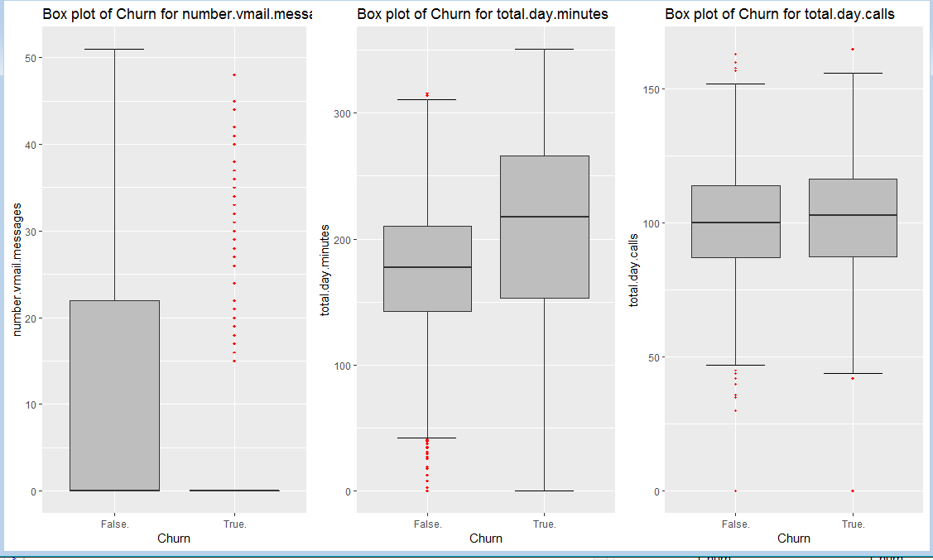

**(FIG -1)**

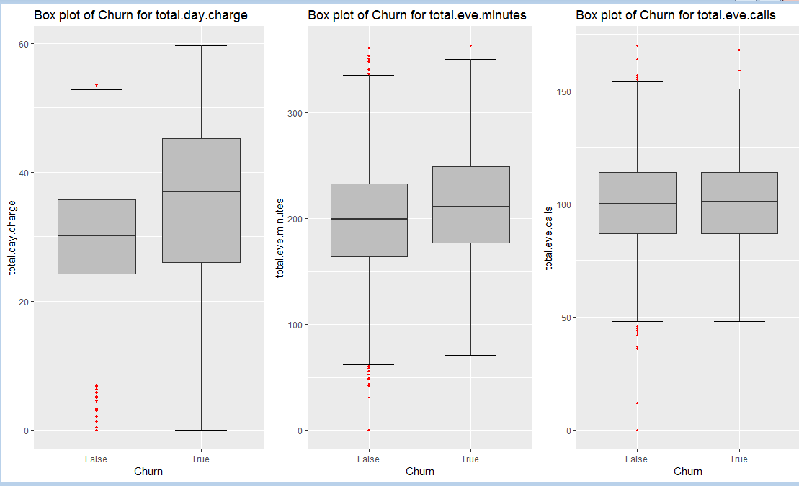

**(FIG-2)**

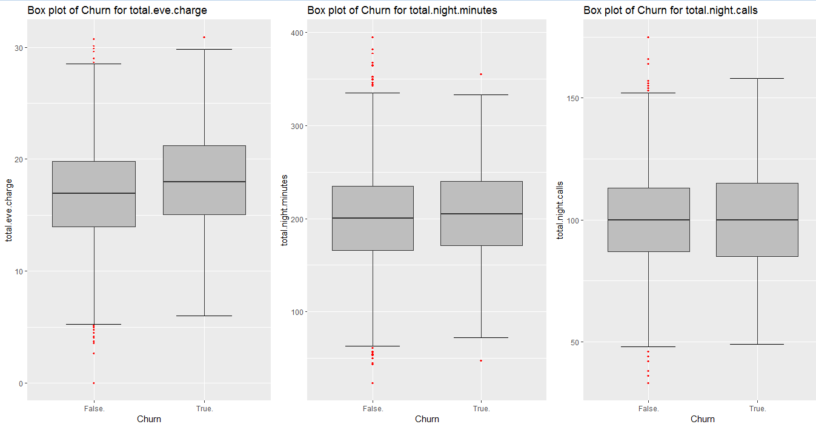

**(FIG-3)**

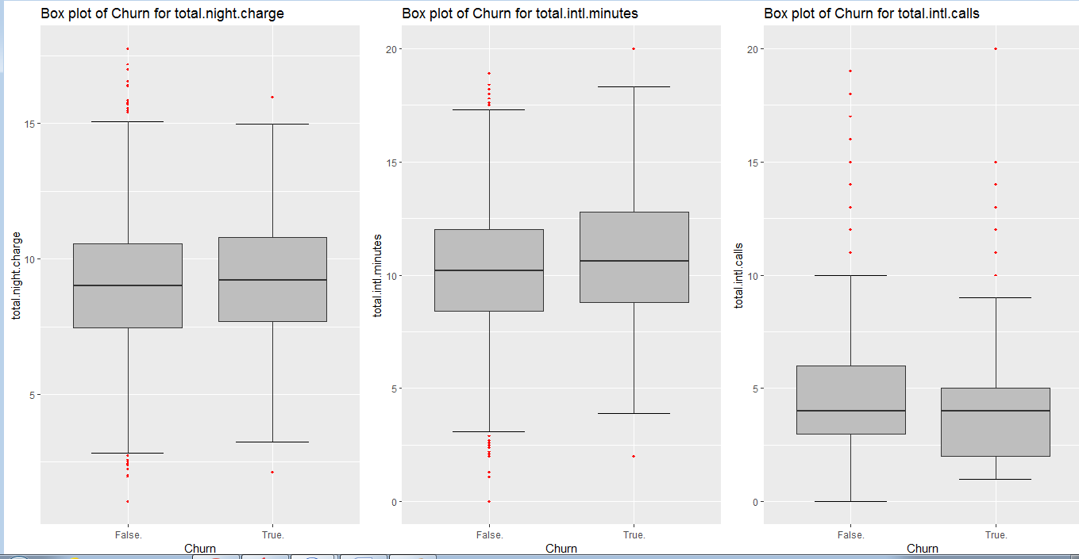

**(FIG-4)**

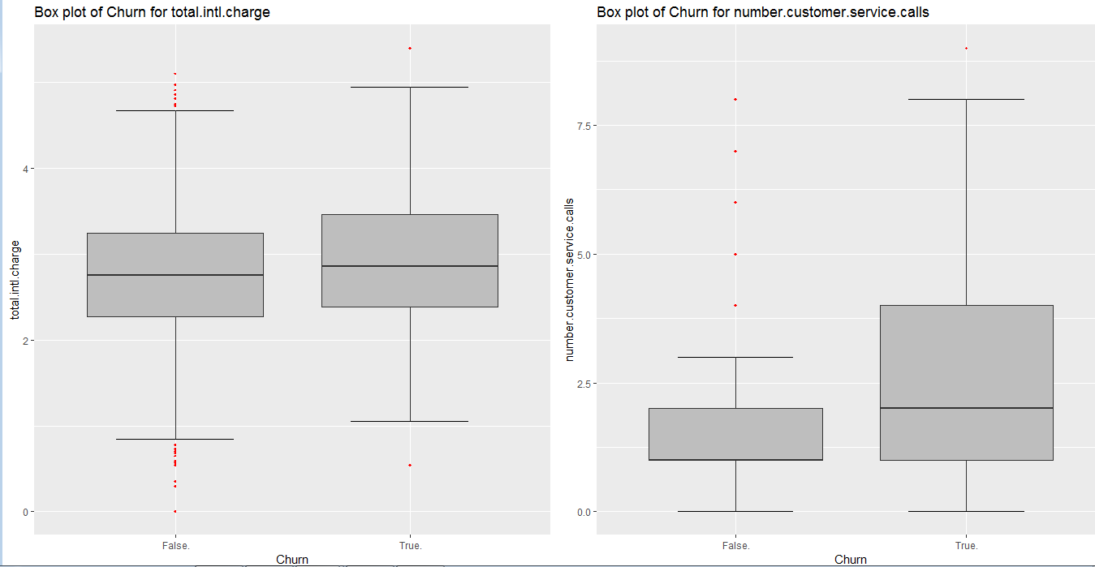

**(FIG-4)**

**2.1.3 Feature Selection**

* In feature selection method I checked the association between two variables.
* For continuous variables I used correlation analysis which tells the direction and strength of the linear relationship between two quantitative variables.
* I found total.day.minutes and total.day.charge, total.eve.minutes and total.eve.charge , total.night.minutes and total.night.charge, total.Intl.minutes and total.Intl.charge are highly correlated with each other .
* So I remove total.day.minutes, total.eve.minutes, total.night.minutes and total.Intl.minutes from the train and test dataset.
* For Categorical variables I used Chi-Square test which compare two variables in a contingency table to see if they are related or not.

**Correlation analysis plot:**

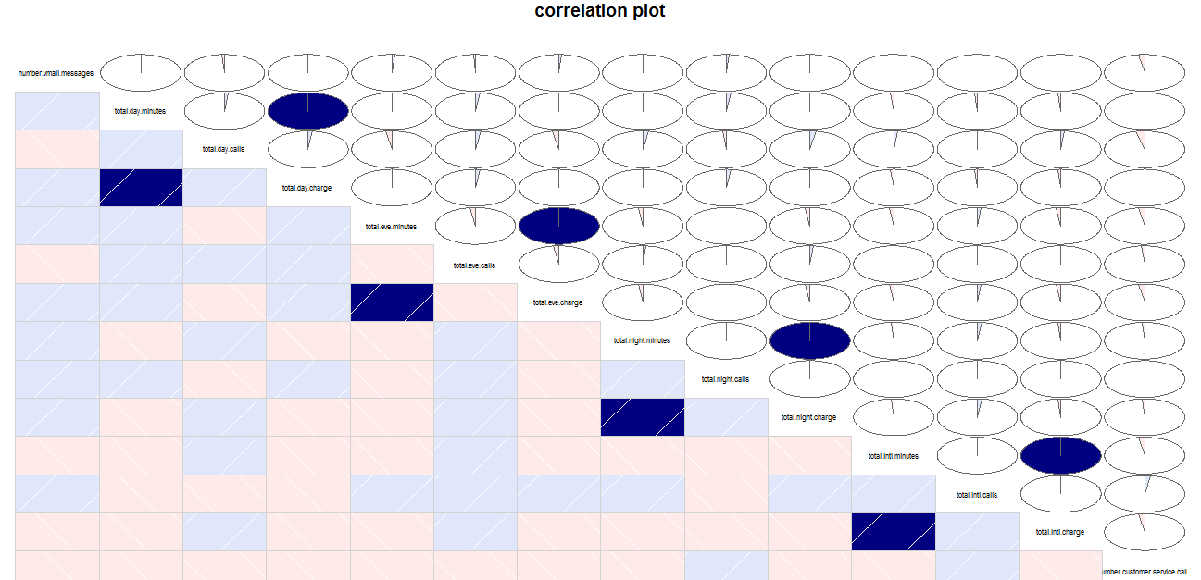

**#Removal of total.day.minutes, total.eve.minutes, total.night.minutes and total.Intl.minutes variables from train and test dataset.**

**train=train[,-c(4,7,10,13)]**

**train=train[,-c(4,7,10,13)]**

**Chi-Square Test**

> factor_index=sapply(train,is.factor)

> factor_data=train[,factor_index]

> for (i in 1:2)

+ {

+ print(names(factor_data)[i])

+ print(chisq.test(table(factor_data$Churn,factor_data[,i])))

+ }

**Output**

[1] "international.plan"

Pearson's Chi-squared test with Yates' continuity correction

data: table(factor_data$Churn, factor_data[, i])

X-squared = 222.57, df = 1, p-value < 2.2e-16

[1] "voice.mail.plan"

Pearson's Chi-squared test with Yates' continuity correction

data: table(factor_data$Churn, factor_data[, i])

X-squared = 34.132, df = 1, p-value = 5.151e-09

* In the above output I saw the P-value for the two variables is greater than 0.05 so I reject alternate hypothesis and select the null hypothesis i.e. the variables are independent with each other.

**2.1.4 Class Imbalance**

**table(train$Churn)**

**False. True.**

**2850 483**

As shown above my target variable of train data is having two class i.e False and True but here the problem is out of 3333 observations one class is of 2850 observations and another one is only 483.

Here class imbalance occurs and the model evaluation methods do not accurately measure model performance when faced with imbalanced datasets.

Standard classifier algorithms like Decision Tree and logistic Regression have a bias towards classes which have number of instances. They tend to only predict the majority class data. The features of the minority class are treated as noise and are often ignored. Thus, there is a high probability of misclassification of the minority class as compared to the majority class.

**Approach to handling Imbalanced class**

* **Under-Sampling**

Under sampling aims to balance class distribution by randomly eliminating majority class examples . This is done until the majority and minority class instances are balanced.

**R code for Undersampling :**

**library(ROSE)**

**under = ovun.sample(Churn~.,data=train,method='under',N=966)$data**

Here my minority class is having 483 observations. So, to balanced the instance I take N = 966.

**Balanced data after Under-Sampling:**

**table(under$Churn)**

**False. True.**

**483 483**

* **Over-Sampling**

Over-Sampling increases the number of instances in the minority class by randomly replicating them in order to present a higher representation of the minority class in the sample.

**R code for Over-Sampling:**

**Over = ovun.sample(Churn~.,data=train,method='over',N=5700)$data**

Here my majority class is having 2850 observations. So, to balanced the instances I take N = 5700.

**Balanced data after Over-Sampling:**

**table(over$Churn)**

**False. True.**

**2850 2850**

* **Both Sampling**

This method is a combination of both oversampling and undersampling methods. Using this method, the majority class is undersampled without replacement and the minority class is oversampled with replacement.

**R code for Both Sampling**

**both=ovun.sample(Churn~.,data=train,method='both',p=0.5,seed=1234, N=3333)$data**

**Balanced data after Both Sampling:**

**table(both$Churn)**

**False. True.**

**1663 1670**

* **ROSE(Random Over Sampling Examples)**

Rose sampling method generates data synthetically and provides a better estimate of original data.

This method is used to avoid overfitting when adding exact replicas of minority instances to the main dataset.

**R code for ROSE**

**rose=ROSE(Churn~.,data=train,N=3500,seed=1321)$data**

**Balanced data after ROSE:**

**table(rose$Churn)**

**False. True.**

**1816 1684**

**2.2 Modeling**

**2.2.1 Model Selection**

I am selecting the Classification model for Churn reduction project to predict the churn score based on usage pattern as my target variable is having binary class.

For Classification model I am going to apply the Logistic Regression, Decision tree, Random Forest and Naïve Bayes .

**2.2.2 Model Evaluation**

Model evaluation is the process of choosing between models, different model types and features. Better evaluation processes lead to better, more accurate models in applications.

**RandomForest**

**Random Forest on rose data**

> rf=randomForest(Churn~.,rose,importance=TRUE,ntree=500)

> confusionMatrix(predict(rf,test),test$Churn)

Confusion Matrix and Statistics

Reference

Prediction False. True.

False. 1256 78

True. 187 146

Accuracy : 0.841

95% CI : (0.8226, 0.8583)

No Information Rate : 0.8656

P-Value [Acc > NIR] : 0.9982

Kappa : 0.4332

Mcnemar's Test P-Value : 3.259e-11

Sensitivity : 0.8704

Specificity : 0.6518

Pos Pred Value : 0.9415

Neg Pred Value : 0.4384

Prevalence : 0.8656

Detection Rate : 0.7534

Detection Prevalence : 0.8002

Balanced Accuracy : 0.7611

'Positive' Class : False.

**Random Forest on Under_Sampling**

rf=randomForest(Churn~.,under,importance=TRUE,ntree=100)

> confusionMatrix(predict(rf,test),test$Churn)

Confusion Matrix and Statistics

Reference

Prediction False. True.

False. 1255 81

True. 188 143

Accuracy : 0.8386

95% CI : (0.8201, 0.856)

No Information Rate : 0.8656

P-Value [Acc > NIR] : 0.9993

Kappa : 0.4228

Mcnemar's Test P-Value : 1.027e-10

Sensitivity : 0.8697

Specificity : 0.6384

Pos Pred Value : 0.9394

Neg Pred Value : 0.4320

Prevalence : 0.8656

Detection Rate : 0.7528

Detection Prevalence : 0.8014

Balanced Accuracy : 0.7541

'Positive' Class : False.

**RandomForest on Over_Sampling**

> rf=randomForest(Churn~.,over,importance=TRUE,ntree=100)

> confusionMatrix(predict(rf,test),test$Churn)

Confusion Matrix and Statistics

Reference

Prediction False. True.

False. 1437 100

True. 6 124

Accuracy : 0.9364

95% CI : (0.9236, 0.9476)

No Information Rate : 0.8656

P-Value [Acc > NIR] : < 2.2e-16

Kappa : 0.6678

Mcnemar's Test P-Value : < 2.2e-16

Sensitivity : 0.9958

Specificity : 0.5536

Pos Pred Value : 0.9349

Neg Pred Value : 0.9538

Prevalence : 0.8656

Detection Rate : 0.8620

Detection Prevalence : 0.9220

Balanced Accuracy : 0.7747

'Positive' Class : False.

**RandomForest on Both_Sampling**

> rf=randomForest(Churn~.,both,importance=TRUE,ntree=100)

> confusionMatrix(predict(rf,test),test$Churn)

Confusion Matrix and Statistics

Reference

Prediction False. True.

False. 1418 93

True. 25 131

Accuracy : 0.9292

95% CI : (0.9158, 0.9411)

No Information Rate : 0.8656

P-Value [Acc > NIR] : < 2.2e-16

Kappa : 0.651

Mcnemar's Test P-Value : 6.922e-10

Sensitivity : 0.9827

Specificity : 0.5848

Pos Pred Value : 0.9385

Neg Pred Value : 0.8397

Prevalence : 0.8656

Detection Rate : 0.8506

Detection Prevalence : 0.9064

Balanced Accuracy : 0.7837

'Positive' Class : False.

In the above four model of RandomForest I found rose data gave the better Specificity than other three. So, for other model building I used rose data.

**Decision Tree on rose data**

> library(C50)

> mo=C5.0(Churn~.,rose,trails=100,rules=TRUE)

> confusionMatrix(predict(mo,test),test$Churn)

Confusion Matrix and Statistics

Reference

Prediction False. True.

False. 1321 82

True. 122 142

Accuracy : 0.8776

95% CI : (0.8609, 0.893)

No Information Rate : 0.8656

P-Value [Acc > NIR] : 0.079374

Kappa : 0.5109

Mcnemar's Test P-Value : 0.006323

Sensitivity : 0.9155

Specificity : 0.6339

Pos Pred Value : 0.9416

Neg Pred Value : 0.5379

Prevalence : 0.8656

Detection Rate : 0.7924

Detection Prevalence : 0.8416

Balanced Accuracy : 0.7747

'Positive' Class : False.

**Naïve Bayes on rose data**

> nb=naiveBayes(Churn~.,data=rose)

> confusionMatrix(predict(nb,test),test$Churn)

Confusion Matrix and Statistics

Reference

Prediction False. True.

False. 1178 89

True. 265 135

Accuracy : 0.7876

95% CI : (0.7672, 0.8071)

No Information Rate : 0.8656

P-Value [Acc > NIR] : 1

Kappa : 0.3146

Mcnemar's Test P-Value : <2e-16

Sensitivity : 0.8164

Specificity : 0.6027

Pos Pred Value : 0.9298

Neg Pred Value : 0.3375

Prevalence : 0.8656

Detection Rate : 0.7067

Detection Prevalence : 0.7600

Balanced Accuracy : 0.7095

'Positive' Class : False.

**Logistic Regression on ROSE**

> lgrose=glm(Churn~.,data=rose,family="binomial")

> prediction=predict(lgrose,newdata=test,type="response")

> prediction=ifelse(prediction>0.5,1,0)

> confmatrix=table(test$Churn,prediction)

> confmatrix

**prediction**

**0 1**

**False. 1192 251**

**True. 76 148**

In the above confusionmatrix

TP= 1192

TN=148

FP=76

FN=251

> Accuracy=(TN+TP)/(TN+TP+FN+FP)

> Accuracy

[1] 0.8038392

> Specificity=TN/(TN+FP)

> Specificity

[1] 0.6607143

> Sensitivity=TP/(TP+FN)

> Sensitivity

[1] 0.8260568

**Random Forest in python**

rf=RandomForestClassifier(n_estimators=100).fit(X_train,Y_train)

prediction=rf.predict(X_test)

cm=pd.crosstab(Y_test,prediction)

cm

**Confusion matrix**

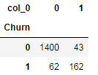

Output

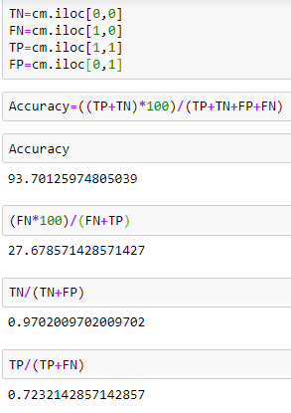

**Conclusion**

From the model evaluation the results are as follows;

|  |  |  |  |
| --- | --- | --- | --- |
| Model Name | Accuracy | Sensitivity | Specificity |
| RandomForest | 84.1 | 87.04 | 65.18 |
| Decision Tree | 87.76 | 91.55 | 63.39 |
| Naïve Bayes | 78.76 | 81.64 | 60.27 |
| Logistic Regression | 80.38 | 82.60 | 66.07 |

From the above result I found RandomForest, Decision Tree and Logistic Regression gives the best result for the Churn Reduction problem.

I choose RandomForest model as the best model for this project as the Specificity and accuracy is better than other models and as per the business requirement my positive class is False.

**Appendix-1-Extra Figures**

**Variables without outliers(some figures)**

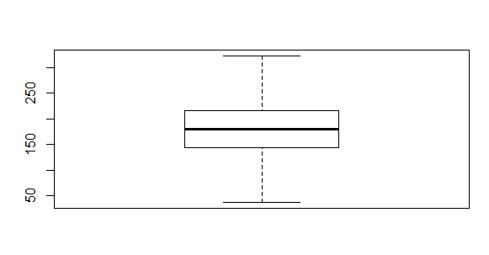

(**Total.day.minutes)**

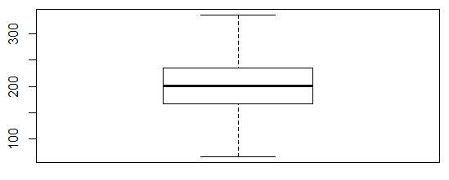**(Total.eve.minutes)**

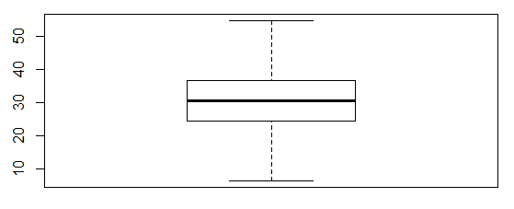

**(Total.day.charges)**

**Data before balanced**

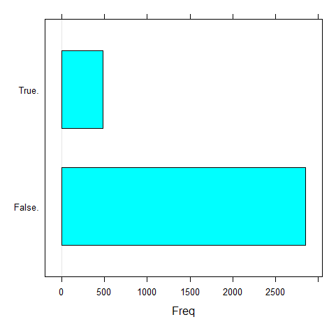

**Data after balanced**

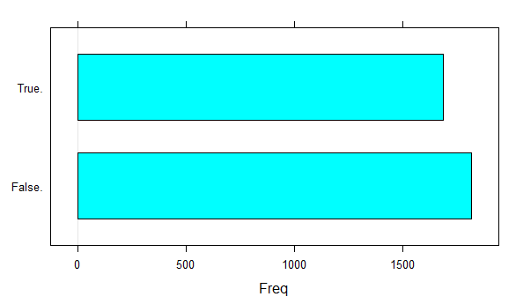

**Variable Importance Plot RandomForest**

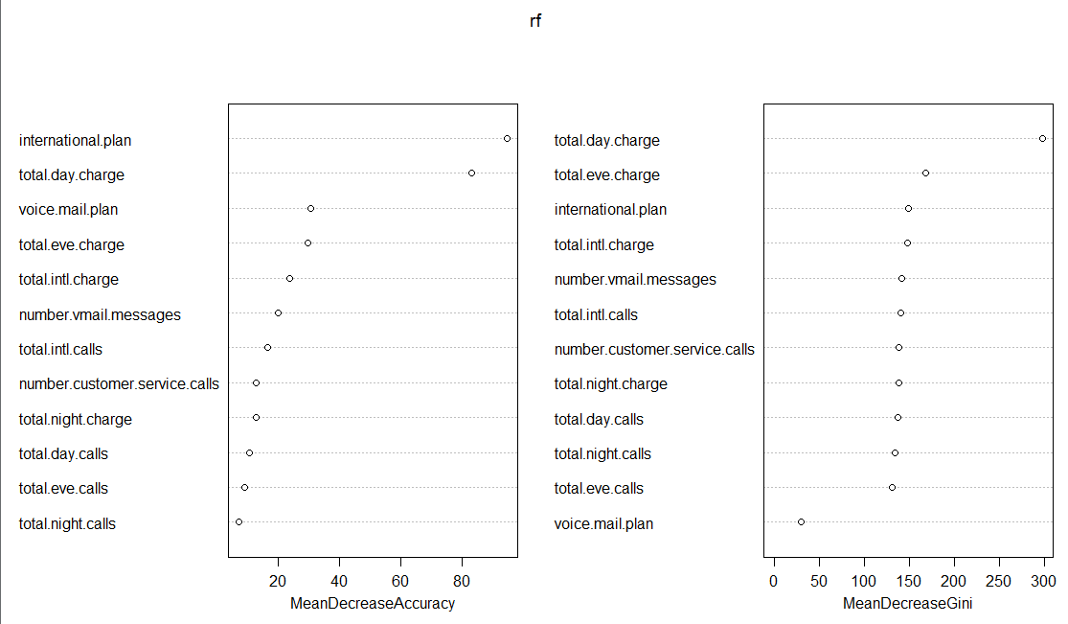

**Appendix 2 – R Code**

> setwd("D:/PROJECT")

> train=read.csv("Train_data.csv",header=T)

> test=read.csv("Test_data.csv",header=T)

> train=train[,-c(1,2,3,4)]

> numeric_index=sapply(train,is.numeric)

> numeric_data=train[,numeric_index]

> cnames=colnames(numeric_data)

> cnames

> library(ggplot2)

> for(i in 1:length(cnames))

+ {assign(paste0("gn", i),ggplot(aes_string(y = (cnames[i]),x = "Churn")

+ ,data = subset(train))+ stat_boxplot(geom = "errorbar", width = 0.5)+

+ geom_boxplot(outlier.colour="RED",

+ fill ="grey", outlier.shape = 18, outlier.size = 1, notch = FALSE)+theme(legend.position = 'bottom')

+ +

+ labs(y = cnames[i],x = 'Churn')+

+ ggtitle(paste("Box plot of Churn for", cnames[i])))}

>

> library(gridExtra)

> gridExtra::grid.arrange(gn1,gn2,gn3,ncol = 3)

> gridExtra::grid.arrange(gn4,gn5,gn6,ncol = 3)

> gridExtra::grid.arrange(gn7,gn8,gn9,ncol = 3)

> gridExtra::grid.arrange(gn10,gn11,gn12,ncol = 3)

> gridExtra::grid.arrange(gn13,gn14,ncol = 2)

> library(DMwR)

> for(i in cnames)

+ {val=train[,i][train[,i]%in% boxplot.stats(train[,i])$out]

+ train[,i][train[,i]%in%val]=NA}

> train=knnImputation(train,k=3)

> library(corrgram)

> corrgram(train[,numeric_index],order = F,upper.panel = panel.pie,

+ main="correlation plot")

> train=train[,-c(4,7,10,13)]

> test=test[,-c(1,2,3,4)]

> test=test[,-c(4,7,10,13)]

> factor_index=sapply(train,is.factor)

> factor_data=train[,factor_index]

> for (i in 1:2)

+ {

+ print(names(factor_data)[i])

+ print(chisq.test(table(factor_data$Churn,factor_data[,i])))

+ }

> library(randomForest)

> library(ROSE)

> library(caret)

> rose=ROSE(Churn~.,data=train,N=3500,seed=1321)$data

> rf=randomForest(Churn~.,rose,importance=TRUE,ntree=500)

> confusionMatrix(predict(rf,test),test$Churn)

> varImpPlot(rf)

**Appendix 3 – Python Code**

import os

import pandas as pd

import numpy as np

import matplotlib as mlt

import matplotlib.pyplot as plt

import seaborn as sn

from imblearn.over_sampling import SMOTE

from sklearn.ensemble import RandomForestClassifier

os.chdir("D:/PROJECT")

train=pd.read_csv("Train_data.csv")

test=pd.read_csv("Test_data.csv")

train=train.drop(['state','account length','area code','phone number'],axis=1)

test=test.drop(['state','account length','area code','phone number'],axis=1)

def cat_to_num(df):

for i in range(0, df.shape[1]):

#print(i)

if(df.iloc[:,i].dtypes == 'object'):

df.iloc[:,i] = pd.Categorical(df.iloc[:,i])

df.iloc[:,i] = df.iloc[:,i].cat.codes

df.iloc[:,i] = df.iloc[:,i].astype('object')

return df

train = cat_to_num(train)

test= cat_to_num(test)

train_class_0 = train[train['Churn'] == 0]

train_class_1 = train[train['Churn'] == 1]

count_class_0, count_class_1 = train.Churn.value_counts()

train_class_1_over = train_class_1.sample(count_class_0,replace=True)

new = pd.concat([train_class_0,train_class_1_over], axis=0)

new.Churn.value_counts()

train=new

cnames=['number vmail messages',

'total day minutes', 'total day calls', 'total day charge',

'total eve minutes', 'total eve calls', 'total eve charge',

'total night minutes', 'total night calls', 'total night charge',

'total intl minutes', 'total intl calls', 'total intl charge',

'number customer service calls']

train_corr=train.loc[:,cnames]

f,ax=plt.subplots(figsize=(7,5))

corr=train_corr.corr()

sn.heatmap(corr,mask=np.zeros_like(corr,dtype=np.bool),cmap=sn.diverging_palette(220,10,as_cmap=True),square=True,ax=ax)

train=train.drop(['total day minutes','total eve minutes','total night minutes','total intl minutes', ],axis=1)

test=test.drop(['total day minutes','total eve minutes','total night minutes','total intl minutes', ],axis=1)

X_train=train.iloc[:,0:12]

Y_train=train.iloc[:,12]

X_test=test.iloc[:,0:12]

Y_test=test.iloc[:,12]

X_train=X_train.astype('int')

Y_train=Y_train.astype('int')

rf=RandomForestClassifier(n_estimators=100).fit(X_train,Y_train)

prediction=rf.predict(X_test)

from sklearn.metrics import confusion_matrix

cm=pd.crosstab(Y_test,prediction)

cm

TN=cm.iloc[0,0]

FN=cm.iloc[1,0]

TP=cm.iloc[1,1]

FP=cm.iloc[0,1]

((TP+TN)*100)/(TP+TN+FP+FN)

(FN*100)/(FN+TP)

TN/(TN+FP)

TP/(TP+FN)